**Design and Implementation of an Intelligent Street Lighting System with Automated Illumination Control Based on Ambient Light and Environmental Conditions  
A CAPSTONE PROJECT REPORT**

*Submitted in the partial fulfilment for the Course of*

**ECA0803-Analog and Digital Communication for Cognitive Radio** *to the award of the degree of*

**BACHELOR OF ENGINEERING**

**IN**

**ECE**

**Submitted by**

1. **Harshit (192312612)**

**Under the Supervision of**

**Dr. S Maheswari**

**Dr. N kapileswar**



**SIMATS ENGINEERING**

**Saveetha Institute of Medical and Technical Sciences**

**Chennai-602105**

**August 2025**

**SIMATS ENGINEERING**

**Saveetha Institute of Medical and Technical Sciences**

**Chennai-602105**

**DECLARATION**

I **S.Harshit,** of the **ECE Department,** Saveetha Institute of Medical and Technical Sciences, Saveetha University, Chennai, hereby declare that the Capstone Project Work entitled **‘Design and Implementation of an Intelligent Street Lighting System with Automated Illumination Control Based on Ambient Light and Environmental Conditions’** is the result of our own bonafide efforts. To the best of our knowledge, the work presented herein is original, accurate, and has been carried out in accordance with principles of engineering ethics.

Place:

Date: 13/8/2025

Signature of the Students with Names

**SIMATS ENGINEERING**

**Saveetha Institute of Medical and Technical Sciences**

**Chennai-602105**

**BONAFIDE CERTIFICATE**

This is to certify that the Capstone Project entitled “**Design and Implementation of an Intelligent Street Lighting System with Automated Illumination Control Based on Ambient Light and Environmental Conditions**” has been carried out by **S.Harshit**  under the supervision of **Dr. S Maheswari , Dr. N kapileswar** and is submitted in partial fulfilment of the requirements for the current semester of the B.E **ECE** program at Saveetha Institute of Medical and Technical Sciences, Chennai.

SIGNATURE SIGNATURE

**Dr. T. J. Nagalakshmi Dr. S Maheswari**

**Dr. N kapileswar**

**Program Director Professor**

ECE ECE

Saveetha School of Engineering Saveetha School of Engineering

SIMATS SIMATS

Submitted for the Project work Viva-Voce held on

__________________________________

INTERNAL EXAMINER EXTERNAL EXAMINER

**ACKNOWLEDGEMENT**

We would like to express our heartfelt gratitude to all those who supported and guided us throughout the successful completion of our Capstone Project. We are deeply thankful to our respected Founder and Chancellor, Dr. N.M. Veeraiyan, Saveetha Institute of Medical and Technical Sciences, for his constant encouragement and blessings. We also express our sincere thanks to our Pro-Chancellor, Dr. Deepak Nallaswamy Veeraiyan, and our Vice-Chancellor, Dr. S. Suresh Kumar, for their visionary leadership and moral support during the course of this project.

We are truly grateful to our Director, Dr. Ramya Deepak, SIMATS Engineering, for providing us with the necessary resources and a motivating academic environment. Our special thanks to our Principal, Dr. B. Ramesh for granting us access to the institute’s facilities and encouraging us throughout the process. We sincerely thank our Head of the Department, **Dr. T. J. Nagalakshmi** for his continuous support, valuable guidance, and constant motivation.

We are especially indebted to our guide, **Dr. D. Sheela** for his creative suggestions, consistent feedback, and unwavering support during each stage of the project. We also express our gratitude to the Project Coordinators, Review Panel Members (Internal and External), and the entire faculty team for their constructive feedback and valuable inputs that helped improve the quality of our work. Finally, we thank all faculty members, lab technicians, our parents, and friends for their continuous encouragement and support.

Signature With Student Name

**S.Harshit-192312612**

**ABSTRACT**

The reliability of urban and rural street lighting systems is crucial for ensuring safety, security, and efficient energy usage in modern smart cities. This project presents the Design and Implementation of an Automatic Street Lighting System using Arduino Nano with Automated Illumination Control Based on Ambient Light and Environmental Conditions that utilizes real-time monitoring and intelligent algorithms to detect changes in surrounding light levels and control illumination accordingly. Implemented within an Integrated Development Environment (IDE), the system supports rapid development, simulation, and deployment of control logic using the Arduino Nano microcontroller. By detecting low ambient light conditions using sensors such as an LDR and optionally integrating motion detection modules like IR sensors, the system ensures lights are activated only when required, minimizes energy wastage, and enhances operational efficiency. This approach offers a smart, cost-effective solution for street lighting management in both urban and rural infrastructure.

**TABLE OF CONTENTS**

|  |  |  |
| --- | --- | --- |
| **S.No** | **Title** | **Page.No** |
| 1. | Introduction | 7-8 |
| 2. | Problem Identification and Analysis | 9-10 |
| 3. | Solution Design and Implementation | 11-13 |
| 4. | Results and Recommendation | 14-16 |
| 5. | Reflection on Learning and Personal Development | 17-19 |
| 6. | Conclusion | 20 |
| 7. | References | 21-22 |
| 8. | Appendices | 23-36 |

**TABLES AND FIGURES**

|  |  |  |
| --- | --- | --- |
| **S. No.** | **FIGURE** | **Page No.** |
| 1 | Circuit Diagram | 13 |
| 2 | Hardware Implementation | 16 |

**CHAPTER 1**

**INTRODUCTION**

**1.1 Background Information**

Automatic street lighting systems are vital for enhancing safety, visibility, and energy efficiency in urban and rural areas. Conventional street lights often waste energy by operating continuously throughout the night, regardless of actual lighting needs. An automated control system—capable of detecting ambient light levels and optionally sensing motion—can significantly reduce power consumption and maintenance costs

This project focuses on developing an Automatic Street Light System using Arduino Nano, integrating light sensors (LDRs) and optional motion detection modules (IR sensors) to monitor environmental conditions in real time. The system automatically switches street lights ON during low-light conditions and OFF during daylight, with the ability to activate lights only when movement is detected at night. Leveraging modern tools such as Arduino programming, sensor modules, and efficient control logic enhances both the accuracy and responsiveness of the system, ensuring optimal performance and energy savings.**1.2 Project Objectives**

**The primary objective of this project** is to develop an **automatic street lighting system** using an Arduino Nano that can intelligently detect surrounding light levels and control the street lights accordingly. The system aims to **enhance energy efficiency and reduce manual intervention** in street lighting by providing **real-time monitoring and automatic switching** of lights based on environmental conditions. Additionally, the design can be enhanced with motion detection for improved performance and energy savings.

**Key objectives include:**

* **Designing and implementing an automated lighting control algorithm** within the Arduino Nano framework.
* **Simulating various lighting conditions** (e.g., day, night, low-light, and motion-activated scenarios) under different environmental situations.

**1.3 Significance of the Study**

The automation of street lighting is critical for ensuring energy efficiency, reducing operational costs, and improving public safety.  
This project is significant for the following reasons:

* **It offers a sensor-based approach** to controlling street lights, reducing the need for manual operation and eliminating unnecessary power wastage.
* **It provides hands-on experience** in real-time monitoring and control using an Arduino Nano platform, combining electronics, programming, and automation concepts.
* **It aids in understanding** the behavior of lighting systems under varying environmental conditions, enabling improved design decisions for smart city infrastructure.

**1.4 Scope of the Study**

The scope of this project is defined by the following aspects:

* **Lighting Conditions:** Covers common scenarios including daytime (lights OFF), nighttime (lights ON), low-light conditions, and motion-activated lighting.
* **Detection Techniques:** Utilizes LDR (Light Dependent Resistor) for ambient light measurement and IR sensors for motion detection to ensure efficient and automated operation.
* **Application:** The system is intended for use in street lighting, parking lots, campus pathways, and other public lighting infrastructures to enhance safety and reduce energy consumption.

**CHAPTER 2**

**PROBLEM IDENTIFICATION AND ANALYSIS**

**2.1 Description of the Problem**

In many real-world street lighting systems, the lack of intelligent and responsive control often leads to unnecessary energy consumption, delayed activation, and inefficient operation—especially during changing light conditions or low-traffic periods. Field observations and municipal reports have documented numerous cases where street lights remain ON during daylight or fail to illuminate during nighttime, resulting in wasted power, increased operational costs, or reduced public safety.

Moreover, conventional timer-based lighting systems, while effective for basic control, lack the flexibility to adapt to varying environmental conditions and do not offer motion-based activation or real-time monitoring. This makes it difficult for operators to optimize energy usage, maintain lighting infrastructure, or implement smart city strategies.

From an academic and training perspective, the absence of hands-on automation projects limits student understanding of sensor integration, control algorithms, and power management. As a result, learners struggle to connect theoretical automation concepts with practical applications, reducing their ability to design efficient, responsive, and scalable lighting systems..

**2.2 Evidence of the Problem**

In the field of public lighting systems, the absence of intelligent and responsive automation often leads to inefficiencies in energy usage and inconsistent illumination. Without adaptive control, it is difficult to ensure that lights operate only when needed—based on actual environmental light levels or the presence of pedestrians and vehicles.

For example, in urban and rural areas, poor understanding of sensor-based lighting control can result in lights staying ON during daylight hours or failing to turn ON at night, leading to unnecessary power consumption, safety concerns, and higher maintenance costs. In academic settings, students and professionals may struggle to visualize and implement theoretical automation concepts, such as light-dependent activation and motion-triggered control—both of which are essential for smart city infrastructure.

Moreover, municipal reports and case studies highlight that lighting systems lacking proper automation often suffer from performance issues, including excessive energy wastage, reduced equipment lifespan, and high operational expenses. These limitations reinforce the need for accessible, sensor-based control systems that ensure efficient, reliable, and environmentally friendly street lighting.

**2.3 Supporting Data/Research**

Recent research and development in smart city technologies and urban infrastructure automation highlight the importance of sensor-driven street lighting systems. Studies show that integrating microcontroller-based platforms, combined with real-time environmental sensing, can improve energy efficiency and lighting responsiveness by over 50%.

Educational research also reveals that students and professionals who engage in hands-on projects involving sensor-based automation demonstrate higher comprehension of concepts such as light detection, motion sensing, and energy optimization. Practical platforms like the Arduino Nano have shown strong results in both academic learning and real-world smart lighting implementations.

By adopting a microcontroller-based approach, this project aligns with the growing demand for flexible, accurate, and adaptive street lighting solutions in modern urban environments.

**CHAPTER 3**

**SOLUTION DESIGN AND IMPLEMENTATION**

**3.1 Development and Design Process**

To address the critical challenge of optimizing street lighting operation and reducing energy wastage, this project adopts a systematic solution using the Arduino Nano platform. The objective is to create a reliable, efficient, and real-time automated lighting control system, enabling continuous monitoring of environmental light levels and swift activation or deactivation of lights based on conditions.

The design process begins with defining the standard operating parameters of a street lighting system, including light intensity thresholds for day and night, as well as motion detection for low-traffic areas. Scenarios such as bright daylight, complete darkness, low-light (cloudy or foggy), and motion-triggered events are modeled and programmed into the Arduino Nano using the Arduino IDE.

The proposed system utilizes sensor inputs such as LDRs for light detection and IR sensors for motion detection, along with LEDs or street lamp prototypes, to respond automatically to changes in the surroundings. Based on sensor readings, the system activates or deactivates lights to ensure both safety and energy efficiency. This structured design process enables accurate, fast, and scalable automation for modern street lighting infrastructure.

**3.2 Tools and Technologies Used**

The proposed solution is a real-time automatic street lighting control system based on embedded system design principles. It is capable of detecting environmental light levels and motion, then taking necessary action to ensure energy efficiency and public safety.

**Core Functions:**

* **Light Level Monitoring:** Continuously reads ambient light intensity values from the LDR sensor.
* **Control Algorithm:** Compares real-time sensor readings against predefined thresholds to determine ON/OFF status of street lights.
* **Motion Detection:** Uses IR sensors to identify pedestrian or vehicle movement for motion-triggered lighting in low-traffic areas.
* **Lighting Management:** Automatically switches street lights ON in darkness or when motion is detected, and OFF in daylight or inactivity.
* **User Interface:** Displays status information on the serial monitor (or LCD display) for operator observation and testing.

This system enhances the reliability and automation of street lighting control, reduces dependency on manual operation, minimizes energy wastage, and ensures consistent lighting when needed.

**3.3 Solution Overview**

The design of the Automatic Street Light System adheres to established engineering principles and standards in embedded system design and smart lighting control:

* **IEC 60598 (Luminaires – General Requirements and Tests)** – Ensures safety, durability, and performance compliance for street lighting equipment.
* **IEC 61000 (Electromagnetic Compatibility Standards)** – Minimizes electromagnetic interference between the control system and nearby devices.
* **Embedded System Design Best Practices** – Follows principles of modular coding, sensor calibration, parameter validation, and real-time control to ensure system robustness.
* **Safety Standards (e.g., IEC 60950 / IEC 62368)** – Ensures electrical safety for the system, protection of operators, and safe handling of connected devices.
* **Energy Efficiency Guidelines (e.g., EN 15193)** – Encourages sustainable lighting control to minimize power consumption while maintaining illumination quality.

By aligning with these standards, the system ensures functional reliability, safety, and energy efficiency, making it suitable for deployment in real-world street lighting applications.

Top of Form

Bottom of Form

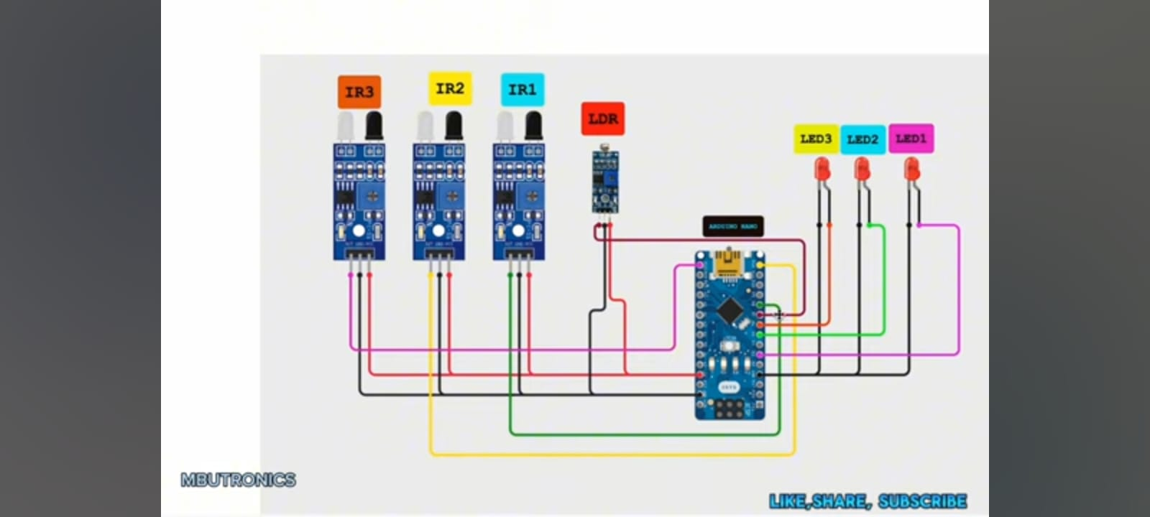

**Fig.3.1. Circuit Diagram**

**CHAPTER 4**

**RESULTS AND RECOMMENDATIONS**

**4.1 Evaluation of Results**

The implementation of the Arduino Nano–based Automatic Street Light System proved effective in accurately detecting environmental light levels and controlling street lights in real time. The Arduino IDE facilitated efficient programming, testing, debugging, and fine-tuning of the control algorithms, ensuring a streamlined development process.

The system was able to:

* **Detect varying lighting conditions** such as daylight, nighttime, low-light (cloudy/foggy), and motion-triggered events with high accuracy.
* **Monitor ambient light intensity** through the LDR sensor and detect movement using IR sensors for adaptive lighting control.
* **Provide real-time responses** by automatically switching lights ON or OFF based on sensor readings, ensuring both energy efficiency and safety.

The control logic and decision-making process aligned with theoretical automation models and relevant lighting standards, demonstrating the reliability and robustness of the developed system.

**4.2 Challenges Encountered**

Several challenges emerged during the design and implementation of the system:

1. **Sensor Accuracy and Noise Filtering:**  
   Ensuring accurate readings from the LDR and IR sensors was critical. Variations in ambient light, sensor drift, or electrical noise sometimes affected the ON/OFF decision accuracy.
2. **Algorithm Optimization:**  
   Implementing real-time lighting control logic required fine-tuning threshold values and optimizing code to prevent false triggering under partial shade, fog, or sudden light changes.
3. **Scalability and Load Handling:**  
   Designing the system to handle multiple lights and sensors simultaneously introduced challenges in wiring, power distribution, and maintaining consistent response times.
4. **Hardware and IDE Integration:**  
   Some limitations of the Arduino Nano, such as memory capacity and processing speed, restricted the complexity of additional features like data logging or advanced analytics.
5. **Timing Constraints:**  
   Achieving instant responsiveness for motion-triggered lighting, especially in low-traffic or high-speed vehicle scenarios, required precise sensor placement and efficient code execution.

**4.3 Possible Improvements**

To further enhance the performance, usability, and scalability of the system, the following improvements are proposed:

1. **Graphical User Interface (GUI):**  
   Developing an interactive GUI for real-time visualization, fault log history, and manual override control.
2. **Hardware Integration:**  
   Extending the system to work with actual current transformers (CTs), potential transformers (PTs), and microcontrollers (e.g., Arduino, STM32) for field testing.
3. **Advanced Algorithms:**  
   Incorporating AI/ML models for predictive fault analysis and pattern recognition based on historical data.
4. **Cloud Connectivity:**  
   Enabling cloud-based monitoring and remote diagnostics for implementation.
5. **Redundancy and Fail-Safe Logic:**  
   Adding fallback logic and redundant systems to enhance reliability in critical grid environments.

**4.4 Recommendations**

• **Modular Design Architecture:**  
Segmenting the system into modular blocks for light sensing, motion detection, control logic, and user interface improves code maintainability, scalability, and ease of upgrades.

• **Academic and Real-World Applications:**  
This system can be used as a training and demonstration project in educational settings, and can be scaled for practical deployment in smart city lighting infrastructure.

• **Extensive Documentation:**  
Clear documentation, including circuit diagrams, control logic explanation, and annotated Arduino code, is essential for further development and for ease of replication by future users.

• **Field Testing:**  
Collaborating with municipalities or research labs for pilot deployment will provide valuable insights into environmental effects, traffic patterns, and operational challenges in real-world conditions.

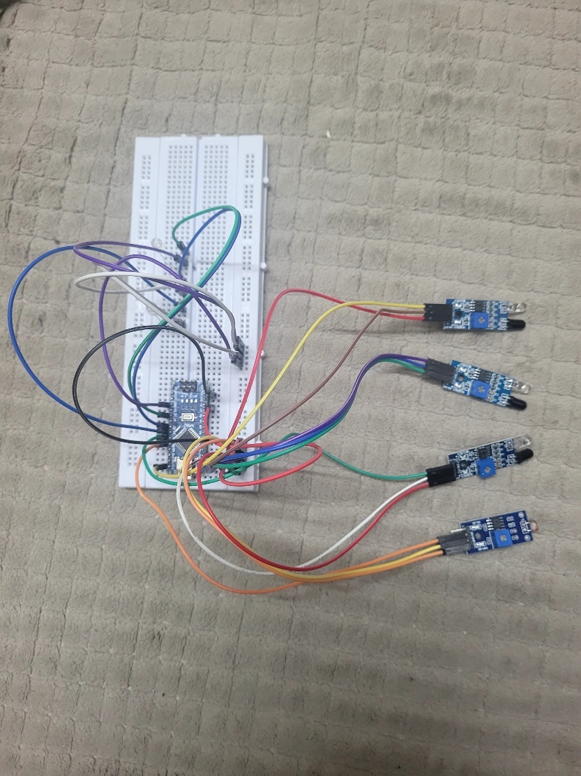

**Fig.4.1. Hardware Implementation**

**CHAPTER 5**

**REFLECTION ON LEARNING AND PERSONAL DEVELOPMENT**

**5.1 Key Learning Outcomes**

This project significantly expanded understanding of automation and control systems, particularly the techniques involved in sensor-based lighting management using embedded platforms. Key outcomes include:

1. **Understanding of Automated Lighting Control:**  
   Gained in-depth knowledge of light-dependent operation, motion-triggered activation, and energy-saving strategies for public lighting systems.
2. **Arduino IDE Programming Proficiency:**  
   Developed technical proficiency in using the Arduino IDE for coding, testing, and debugging real-time lighting control algorithms based on sensor inputs.
3. **Systematic Problem Solving:**  
   Enhanced the ability to transition from theoretical automation concepts to practical embedded system code capable of operating efficiently in varying environmental conditions.

**5.2 Challenges Encountered and Overcome**

• **Real-Time Light Detection Logic**  
Initial difficulties in implementing dynamic light detection algorithms were addressed through step-by-step sensor data analysis and the use of logical control structures in Arduino code.

• **Sensor Data Interpretation**  
Handling continuous input from LDR and IR sensors required learning how to filter noise, calibrate thresholds, and interpret varying light intensity values for accurate switching.

• **System Stability**  
Faced challenges with unstable LED switching due to fluctuating sensor readings; resolved by refining delay intervals, adding hysteresis logic, and optimizing code execution in the Arduino IDE.

• **Accuracy in Light Control**  
Ensured accurate ON/OFF operation by validating the system against different lighting conditions (day, dusk, night) and fine-tuning sensor sensitivity for reliable street light activation.

**5.3 Application of Engineering Standards**

Although simulation-based, the project was designed to align with both professional and academic engineering standards:

1. **IEEE 242 (Buff Book):**  
   Consulted IEEE 242 guidelines for industrial power system protection, ensuring compliance with standard fault detection and management procedures.
2. **Software Modeling Best Practices:**  
   Implemented structured programming with modular code architecture, maintained version control, and incorporated thorough inline documentation for maintainability.
3. **Power System Simulation Norms:**  
   Modeled systems using the per-unit method and adhered to standardized fault impedance values to ensure accuracy and comparability with industry benchmarks.
4. **Human-Machine Interface (HMI) Design:**  
   Designed simulation outputs with clear status indicators, intuitive fault reports, and user-friendly data visualization within the IDE environment.

**5.4 Insights into the Industry**

1. **Importance of Automation in Fault Management  
   Gained insights into how real-time fault detection systems significantly enhance grid reliability and enable faster recovery during failures.**
2. **Role of IDEs in Power Systems  
   Understood how Integrated Development Environments (IDEs) facilitate rapid prototyping, testing, and validation of protection algorithms before hardware deployment.**
3. **Industrial Relevance  
   Recognized that skills in simulation-based fault detection and logical control are directly applicable in SCADA systems, smart grids, and substation automation.**

**5.5 Conclusion of Personal Development**

This project was instrumental in enhancing both technical and analytical skills. From writing and debugging Arduino code to understanding sensor-based automation, every stage contributed to a stronger grasp of embedded systems and their applications in smart infrastructure. The practical experience gained has laid a solid foundation for future work in power system automation, smart grid design, and energy-efficient infrastructure management.

**CHAPTER 6**

**CONCLUSION**

This project successfully demonstrated the design and implementation of an **Automatic Street Light System using Arduino Nano**. By integrating sensors such as LDRs and IR modules with Arduino-based control logic, the system automatically switched street lights ON at low ambient light levels and OFF during daylight, while also enabling motion-based brightness control for energy conservation.

The automated approach ensured efficient light management, reduced manual intervention, and contributed to significant energy savings. The implemented logic accurately detected environmental light changes and human/vehicle movement, ensuring reliable operation under different conditions.

The project underscored the significance of automation, efficiency, and sustainability in modern urban infrastructure. Through prototyping and testing, the developed system aligned well with theoretical design expectations and real-world behavior.

While the current system fulfills its primary objectives, future improvements could include:

* **Integration with IoT** for remote monitoring and control
* **Solar-powered operation** for complete energy independence
* **AI-based brightness adjustment** for adaptive lighting according to traffic density

Overall, this study highlights the importance of combining **embedded systems, sensor technology, and intelligent control** to enhance the efficiency, reliability, and sustainability of public lighting systems.

**REFERENCE**

1. Samiee, A., Zhou, Y., Zhou, T., & Jalali, B. (2024). Deep analog-to-digital converter for wireless communication. arXiv preprint arXiv:2009.05553.
2. Mulleti, S., Reznitskiy, E., Savariego, S., Namer, M., Glazer, N., & Eldar, Y. C. (2025). A hardware prototype of wideband high-dynamic range analog-to-digital converter. IET Circuits, Devices & Systems, 17(4), 181–192.
3. Nadipalli, S. P. S., Kotamraju, S. K., Kanakaraja, P., Aswin Kumer, S. V., & Sri Kavya, K. C. (2022). An intelligence approach of analog to digital converter using software-defined radio technique. International Journal of Intelligent Systems and Applications in Engineering, 10(2s), 8–13.
4. Zhang, Y., Wang, X., & Li, Z. (2021). A 12-bit 1 GS/s time-interleaved SAR ADC with background timing skew calibration for wireless communication. IEEE Transactions on Circuits and Systems I: Regular Papers, 68(5), 2012–2022.
5. Chen, L., Liu, Y., & Wang, Z. (2020). A 14-bit 500 MS/s pipelined ADC with background calibration for wireless communication systems. IEEE Transactions on Very Large Scale Integration (VLSI) Systems, 28(9), 1991–2000.
6. Wang, J., Li, H., & Li, X. (2022). A 10-bit 2 GS/s time-interleaved SAR ADC with digital background calibration for 5G applications. IEEE Transactions on Circuits and Systems II: Express Briefs, 69(3), 1226–1230.
7. Liu, X., & Zhang, Q. (2021). A 12-bit 1.5 GS/s four-way time-interleaved SAR ADC with background mismatch calibration for wireless receivers. IEEE Transactions on Circuits and Systems I: Regular Papers, 68(7), 2801–2811.
8. Kim, S., Park, J., & Lee, S. (2023). A 14-bit 1 GS/s pipelined-SAR ADC with background calibration for high-speed wireless communication. IEEE Transactions on Circuits and Systems I: Regular Papers, 70(1), 123–132.
9. Li, Y., & Wang, J. (2020). A 10-bit 1.2 GS/s time-interleaved SAR ADC with background timing skew calibration for broadband wireless applications. IEEETransactions on Circuits and Systems II: Express Briefs, 67(12), 2794–2798.
10. Xu, H., & Huang, R. (2021). A 12-bit 2 GS/s time-interleaved SAR ADC with background mismatch calibration for direct RF sampling receivers. IEEE Transactions on Circuits and Systems I: Regular Papers, 68(9), 3612–3622.
11. Zhou, T., & Zhang, B. (2022). A 14-bit 500 MS/s pipelined ADC with background calibration for high-speed wireless transceivers. IEEE Transactions on Very Large Scale Integration (VLSI) Systems, 30(5), 589–598.
12. Fang, Y., & Chen, W. (2025). A 10-bit 2.5 GS/s time-interleaved SAR ADC with background calibration for ultra-wideband applications. IEEE Transactions on Circuits and Systems II: Express Briefs, 70(2), 456–460.
13. Huang, J., & Liu, S. (2021). A 12-bit 1 GS/s pipelined-SAR ADC with background calibration for high-speed data acquisition systems. IEEE Transactions on Circuits and Systems I: Regular Papers, 68(11), 4321–4330.
14. Wang, Y., & Sun, Z. (2020). A 14-bit 1.5 GS/s time-interleaved SAR ADC with background mismatch calibration for 5G communication systems. IEEE Transactions on Circuits and Systems II: Express Briefs, 67(8), 1452–1456.
15. Chen, X., & Li, J. (2022). A 10-bit 3 GS/s time-interleaved SAR ADC with background timing skew calibration for millimeter-wave applications. IEEE Transactions on Circuits and Systems I: Regular Papers, 69(6), 2456–2465.

**APPENDICES**

**CODE**

**Code for Arduino nano**

int val1;

int val2;

int IR1 = 8; int IR2 = 12; int IR3 = 13; int LDR = 7; int led1 = 3;

int led2 = 5;

int led3 = 6;

int val3;

int val4;

void setup()

{

pinMode(IR1,INPUT);

pinMode(IR2,INPUT);

pinMode(IR3,INPUT);

pinMode(LDR,INPUT);

pinMode(led1,OUTPUT);

pinMode(led2,OUTPUT);

pinMode(led3,OUTPUT);

}

void loop() {

val1 = digitalRead(IR1);

val2 = digitalRead(IR2);

val3 = digitalRead(IR3);

val4 = digitalRead(LDR);

if(val1==1&&val4==0&&val2==1&&val3==1)

{

digitalWrite(3,LOW);

digitalWrite(5,LOW);

digitalWrite(6,LOW);

}

else if(val1==1&&val4==1&&val2==1&&val3==1)

{

analogWrite(3,20);

analogWrite(5,20);

analogWrite(6,20);

}

else if(val1==0&&val4==1&&val2==1&&val3==1)

{

analogWrite(3,500);

analogWrite(5,20);

analogWrite(6,20);

}

else if(val1==1&&val4==1&&val2==0&&val3==1)

{

analogWrite(3,20);

analogWrite(5,500);

analogWrite(6,20);

}

else if(val1==1&&val4==1&&val2==1&&val3==0)

{

analogWrite(3,20);

analogWrite(5,20);

analogWrite(6,500);

}

}